**WAGNER—**Letter K – Fermata (top line: Allegro con brio)

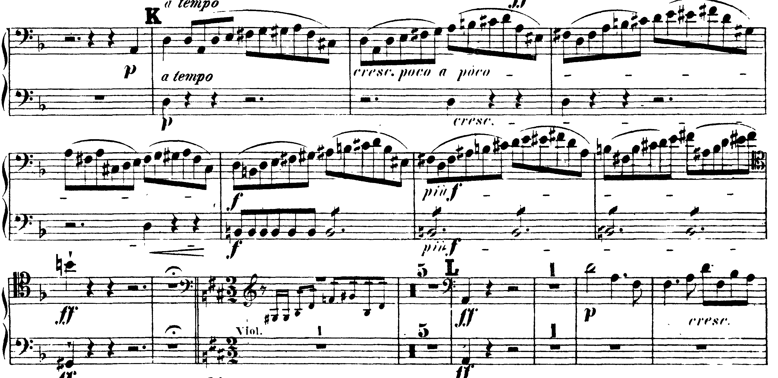

6/4 meter – 2/2 meter (Allegro con brio)

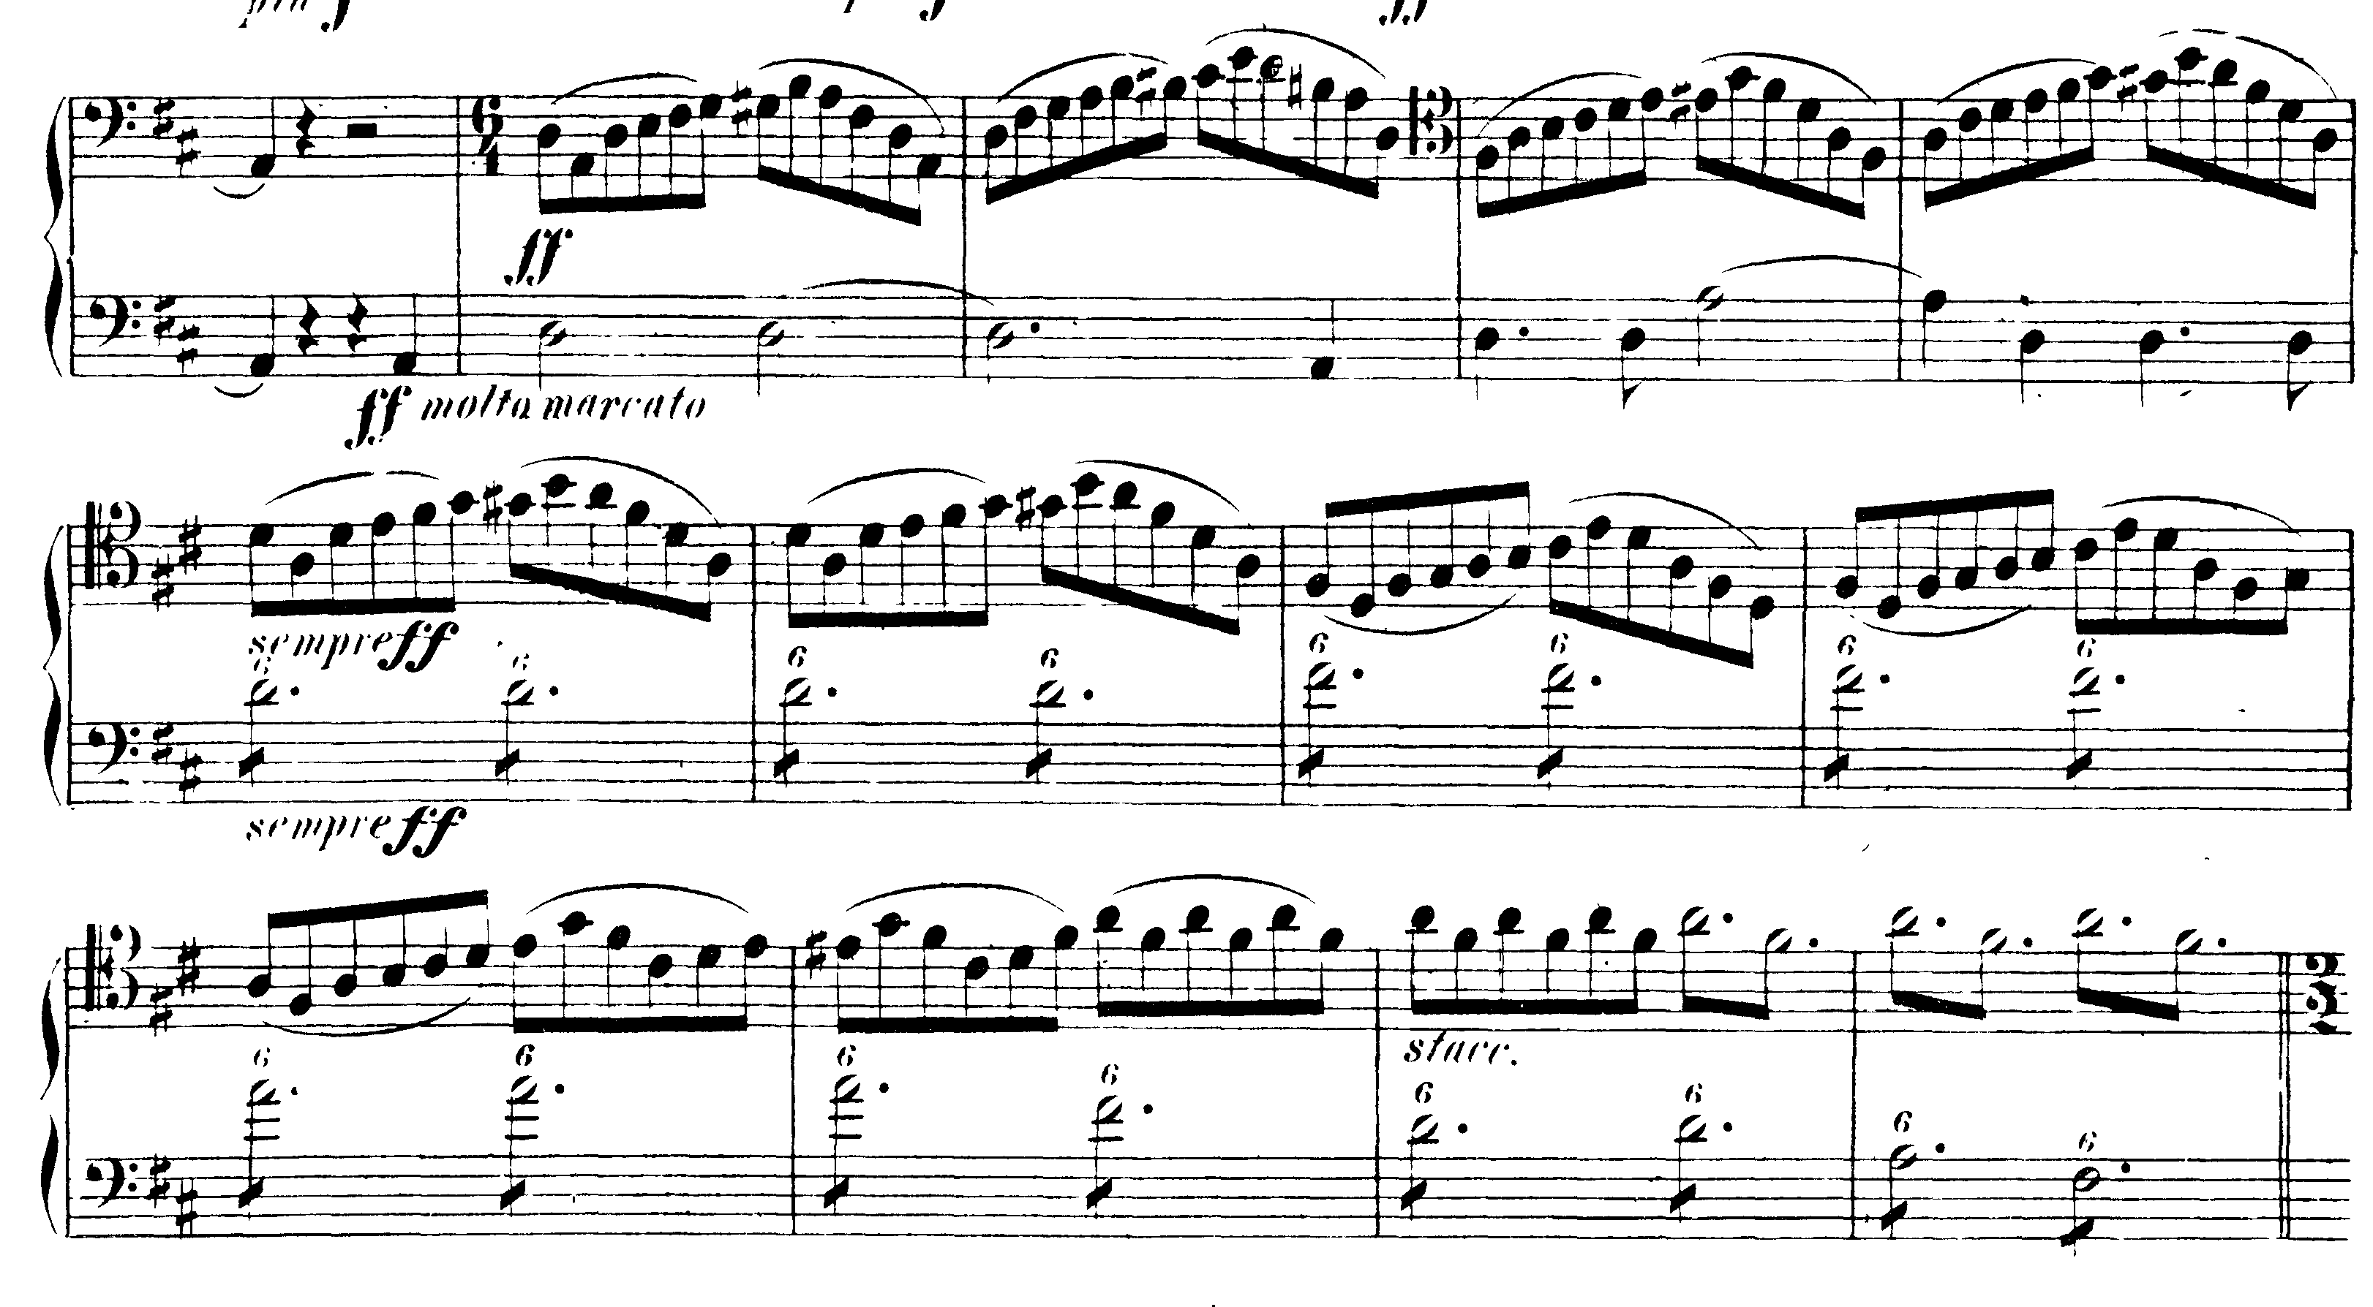

**TCHAIKOVSKY—**Mvt I: 2 before T – 389

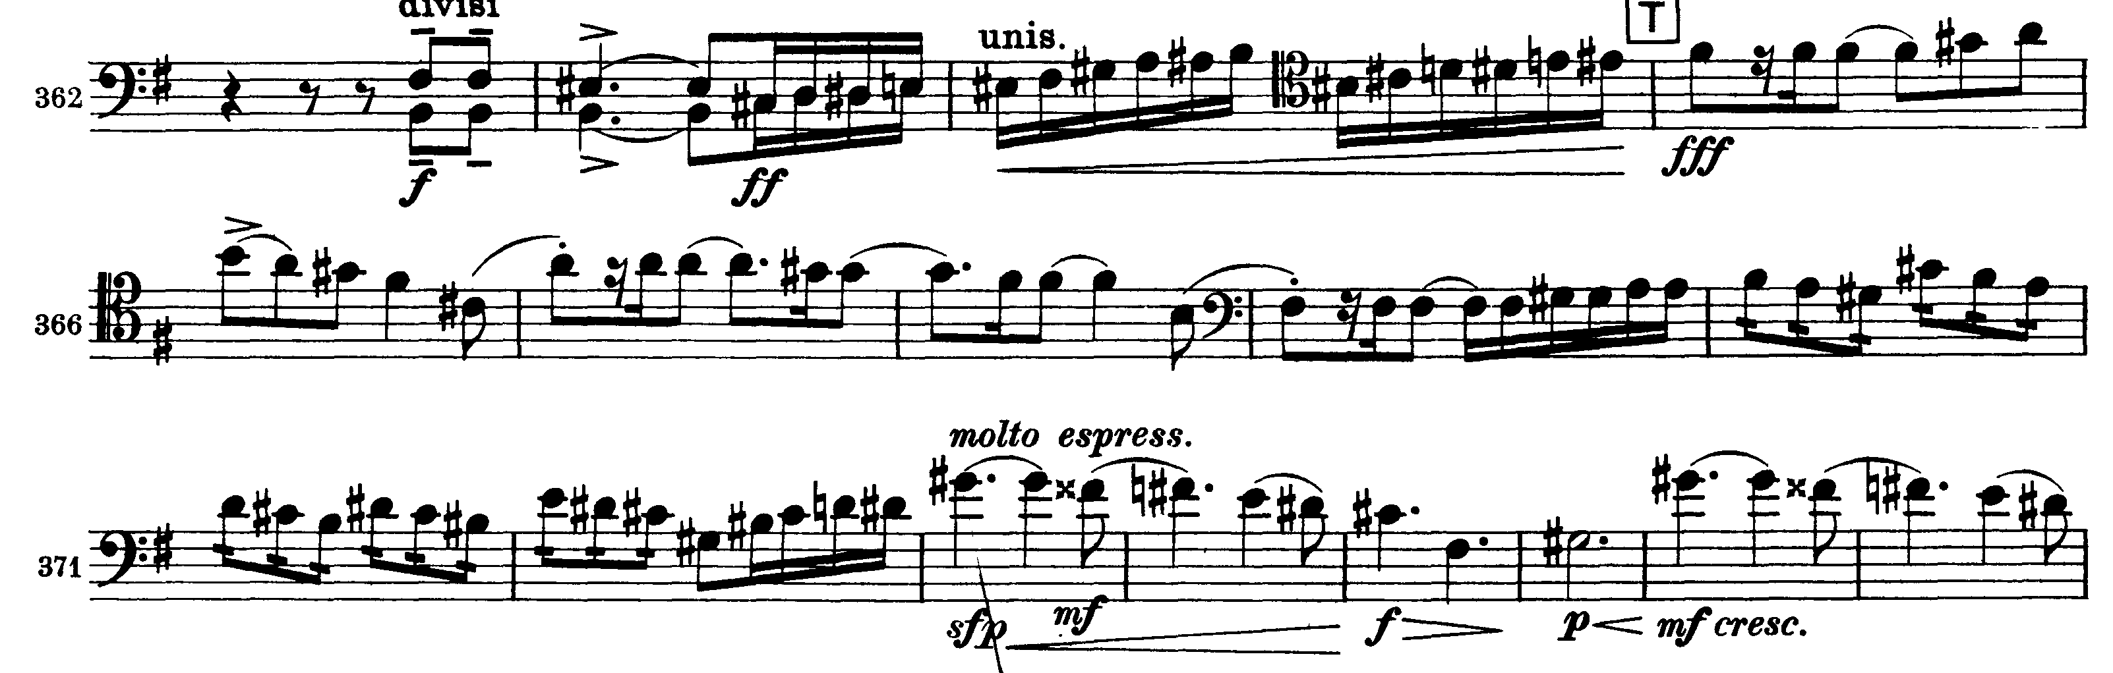

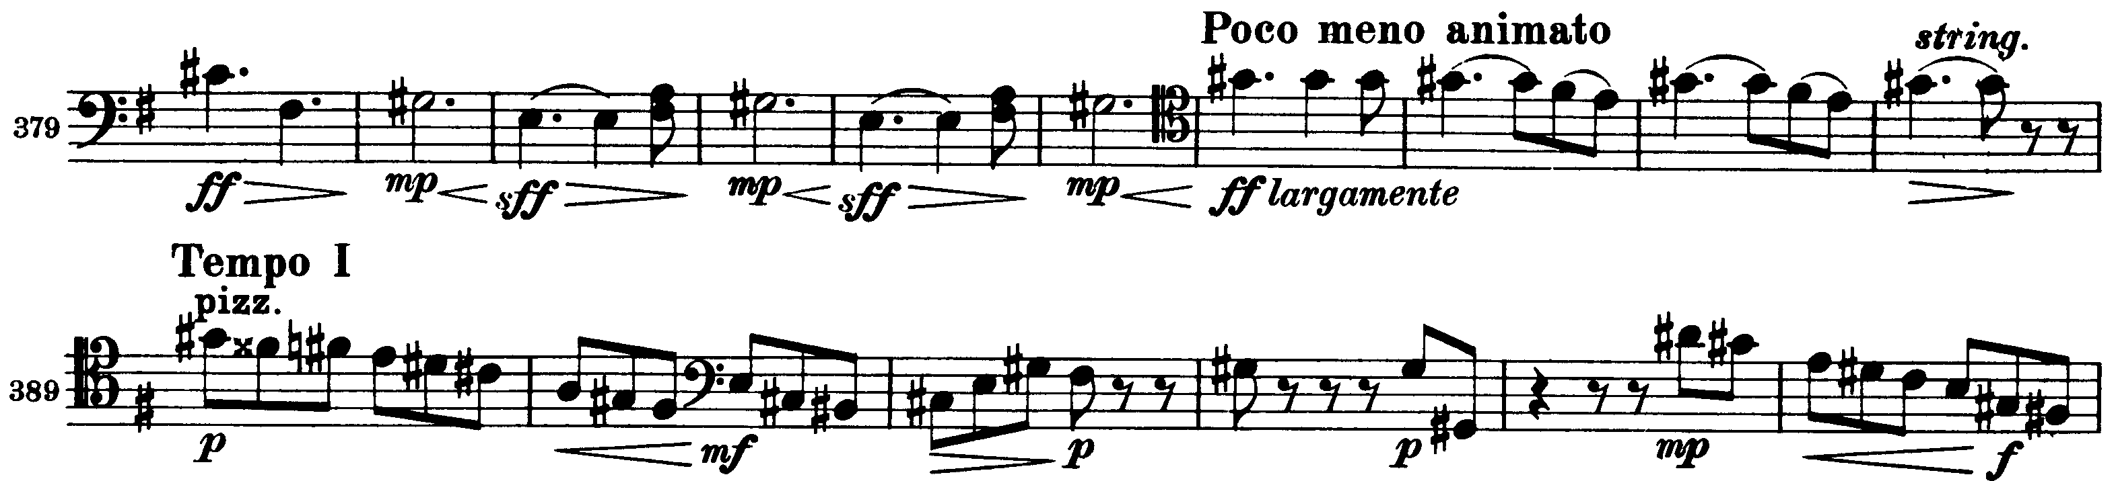

Mvt II: pick-up to 33 – B

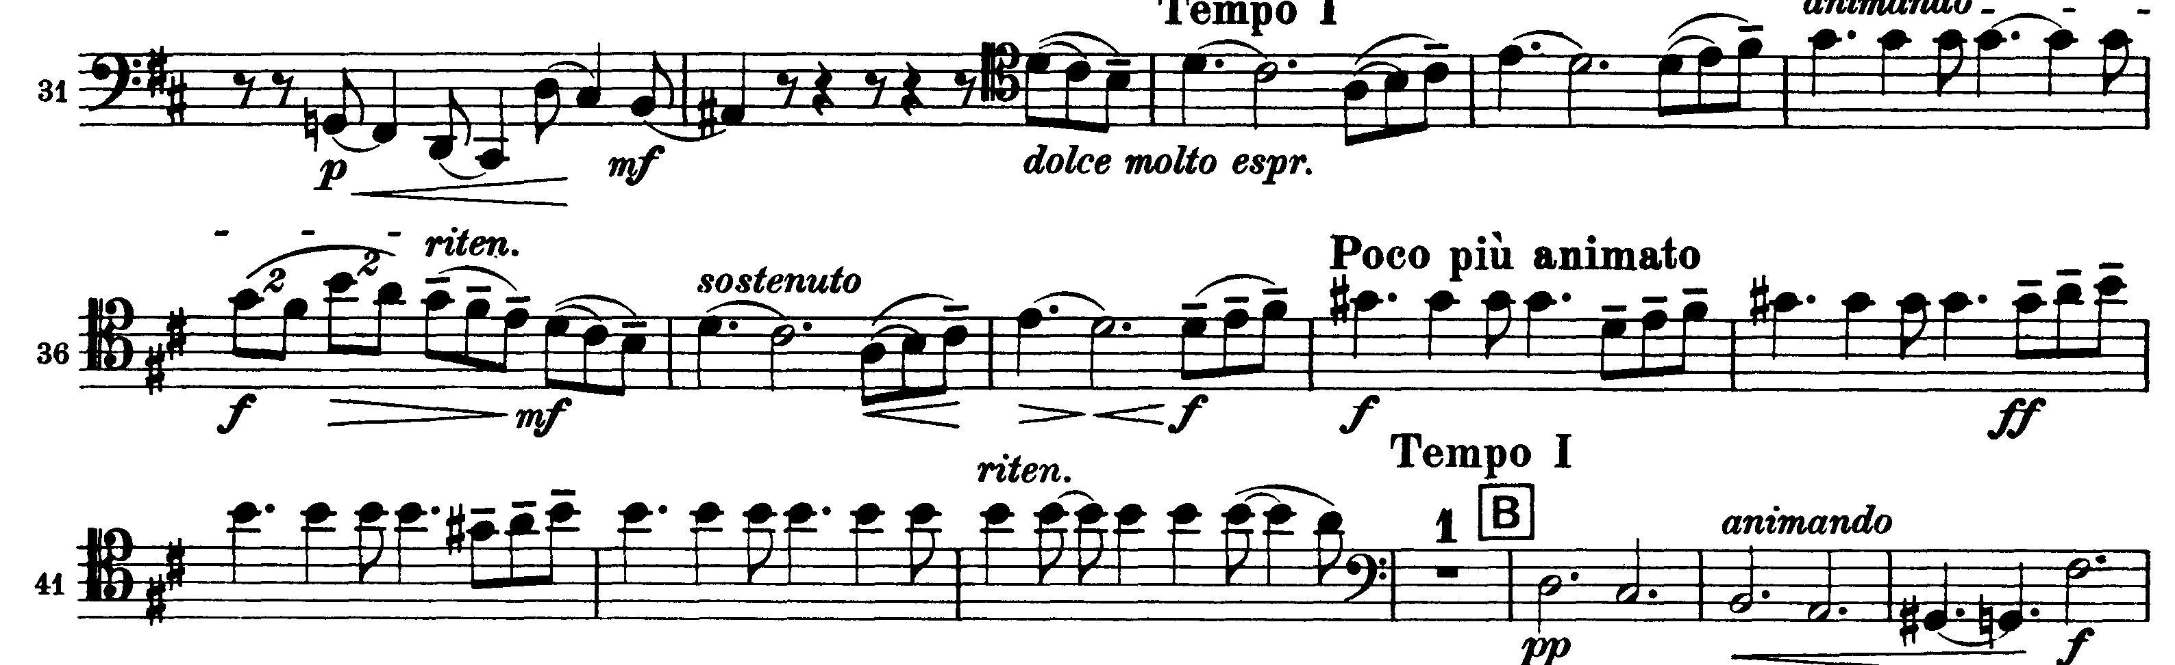

Mvt IV: X – 426

